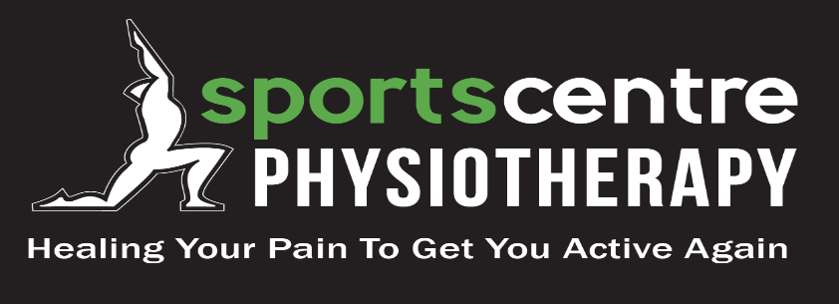
Physiotherapist Wanted
Sports Centre Physiotherapy is seeking a physiotherapist to join our team.
Sports Centre Physiotherapy is an Island leader in sports physiotherapy. Located in Charlottetown, PEI our 3000 square foot facility is busy with active clientele. Our clinic is respected for providing exercise based and effective treatments for over 30 years. We are looking for a physiotherapist that is enthusiastic about helping people, motivated to learn, and excited to contribute to a collaborative team environment.
Our professional team consists of 5 physiotherapists, 1 certified athletic therapist, 1 massage therapist and 3 physiotherapy assistants. We are the physiotherapy clinic for the Holland College Hurricane Athletic program and opportunities to work with sports teams exist. If you are interested in sports this is an excellent opportunity to receive mentorship from a physiotherapist with a diploma in sports physiotherapy and a physiotherapist with a certificate in sports physiotherapy, get field hours, and in-clinic hours with athletes. We are looking for a new graduate or an established physiotherapist that has a previous background in athletics as a participant and/or as a physiotherapist. You will manage a caseload of approximately 14 patients a day while being supported by experienced physiotherapists and physiotherapy assistants. We support new graduates with a payment structure, booking schedule, mentorship and educational opportunities that allow you to gradually develop and become proficient in your new career.
- Paid per patient, (hourly fee until your caseload develops)
- $5000 Sign on bonus
- $2500 annual educational package
- Regular in-house education sessions
- Group insurance
- Job to start as soon as a suitable applicant is found
- Must have successfully completed the national exam
If you have any interest in this opportunity, please contact Colin at the colinphysio@hotmail.com or call 902 370 9355 to discuss. To apply send your resume to colinphysio@hotmail.com. Come work in a fun and supportive environment that promotes your professional and personal growth.

