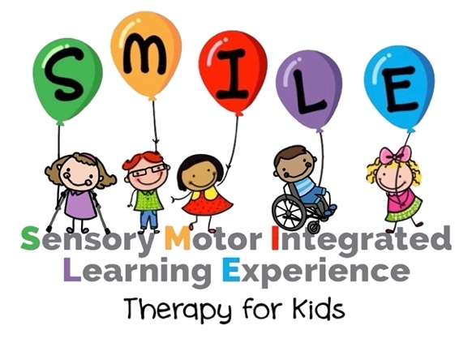

Job Position: Full Time Physical Therapist and Occupational Therapist – Pediatrics
Who We Are:
Kelowna SMILE Therapy for Kids is an interdisciplinary pediatric therapy clinic that serves children 0-18 years of age and their families. Our clients come to us with a wide range of abilities, needs, diagnoses, and backgrounds. We offer dynamic individualized care incorporating intermittent, weekly, and intensive therapy models to support children using the most effective approaches available. SMILE Therapy for Kids was originally founded in Toronto by JoAnne Weltman who is also the co-founder of DMI (Dynamic Movement Intervention) Therapy. We are excited to share this amazing clinical approach with families in Kelowna and all of BC.
Job position description:
We’re looking for a fun and dynamic therapist with a passion for making a difference in the lives of children and families with diverse needs. The position provides:
- Competitive Compensation ($40-50/hr)
- Flexible Scheduling
- Multidisciplinary Team Environment
- Intensive Therapy Opportunities
- DMI Training and Mentorship
- Positive Work Environment
- New Grads Welcome
- Options to work in specialized areas: Aquatic Therapy, Equine Therapy, Community Outreach
Qualifications:
- Graduate from accredited Physical Therapy or Occupational Therapy program
- Eligible for registration with CPTBC or COTBC
- Proven ability and willingness to work as an integral member of a team
- Excellent written and oral communication skills
- Computer skills
- Strong time management skills
- Ability to work independently with little direction, self-motivated, demonstrates initiative
- Excellent ability to organize, co-ordinate and manage program demands in a fast-paced environment
- High level of attention to detail and confidentiality
Location:
Kelowna SMILE Therapy for Kids is located in the center of the sunny Okanagan. Enjoy the beautiful Okanagan Valley including amazing lakes, ski resorts, biking trails, wineries, orchard and more.

Contact/application information:
If you’re interested, please apply by sending a letter of interest or your resume to kelownasmiletherapyforkids@gmail.com Thank you for your interest, and we look forward to meeting you.

