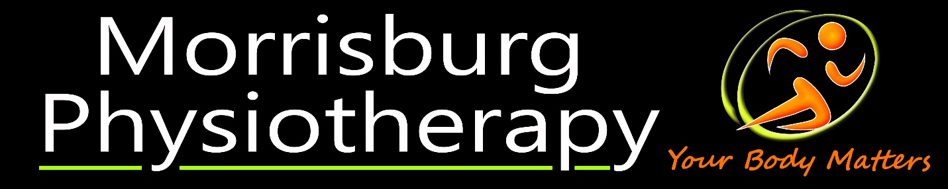
29 Main St. Morrisburg ON K0C1X0 613-643-2000 www.mbpt.ca
Morrisburg Physiotherapy is looking for a part-time to full-time manual physiotherapist to join our dedicated team. We are looking for a candidate that will help us continue our reputation of excellent care treating all members of our community for orthopaedic, vestibular, and neurological conditions. Our clinic is in a newly renovated, fully accessible space, and we pride ourselves on providing a relaxing and inviting space to best promote healing. We combine experience and best practice to develop individualized treatment plans in one-on one 30-minute treatment, and 60-minute assessment appointments.
We are located south of Ottawa in the village of Morrisburg on the St. Lawrence River and surrounded by beautiful countryside. Morrisburg offers the best of rural living with local shopping, schools, arena, and medical services. With only a 30-minute drive to Brockville or Cornwall, 60 minutes to Ottawa, and 90 minutes to Montreal and Kingston, city amenities aren’t far away.
A successful candidate must:
Be registered and in good standing the College of Physiotherapists of Ontario (PT residents eligible so if you are a new grad or graduating soon contact us)
- Have appropriate liability insurance
- Use manual techniques
- Self-motivated
- Excellent communication skills
We offer:
- Competitive salary based on experience
- Education allowance
- Mentorship
- Flexible Monday to Friday hours (no weekends)
- Free Parking

Send CV and cover letter to Victoria Windle, PT at victoria@mbpt.ca

